**Adding a new Structure**

The References page 'List of Structures' displays all the conventional and non-conventional Structures defined by the GSI Cost Tool 'super user'.

If a new Structure is needed, there are 2 elements that need to be completed

1. Create Structure
2. Create Structure / Cost Item Default Factors

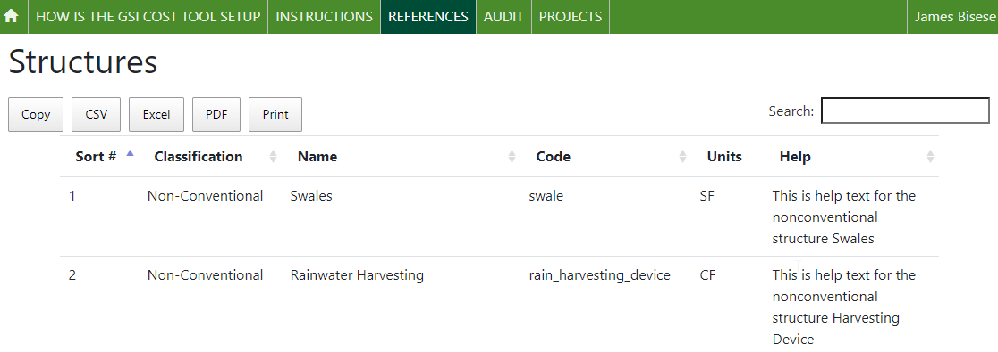

Note: *for each Structure the 'Code' and the 'Name' are unique.*

**Note:** *Once a Structure has been created, and used by users, it should not be deleted. It can be updated – by changing the Name and or Code, but this will change the values displayed in all the Scenarios that already exist.*

***Note****: Once a Structure has been created, additional configuration is required to define the default cost items associated with the structure. A Structure which has no default cost items cannot be used by users.*

***Note****: (this is a function of the UI/UX coding) The 'Code' for a structure CAN NOT be the same as the 'Code' for an Areal Feature. This is a bug in the system that should be fixed.*

New values are entered using the 'GSI Cost Tool Admin Page', which is only available to users who have been granted 'superuser' status. When a superuser logs into the GSI Cost Tool, the menu in the upper right corner of the screen has 3 options. Use the first option to open the 'GSI Cost Tool Admin Page'

On the GSI Cost Tool Admin Page the administrator can add, edit, and delete data. The administrator can select any option by selecting the name of the option, or the 'Change' menu button.

To review, and create, new Structures, select the option from the Site administration list. The information displayed on the admin page is the same shown in the Reference page.

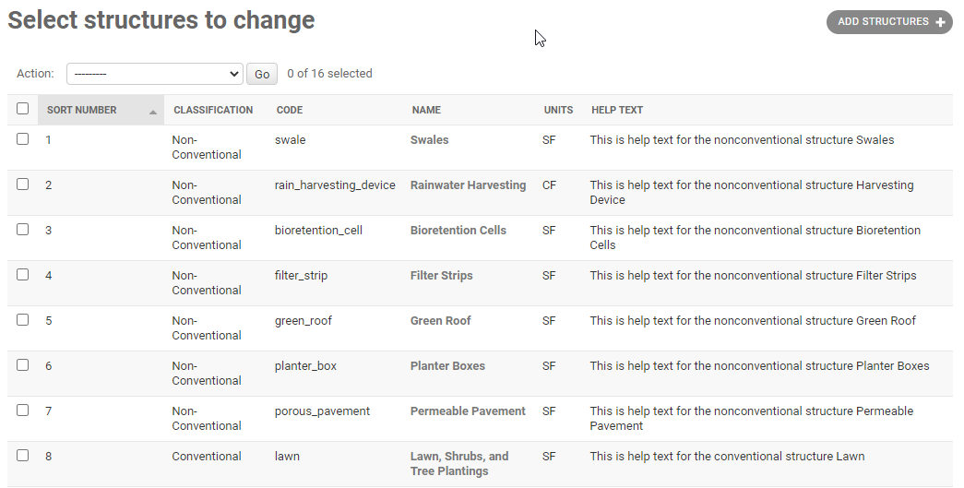

To create new value – use the button 'ADD STRUCTURES' in the upper right corner.

In the screen that opens, enter the information for the new structure. Then hit the SAVE button on the lower right corner of the screen.

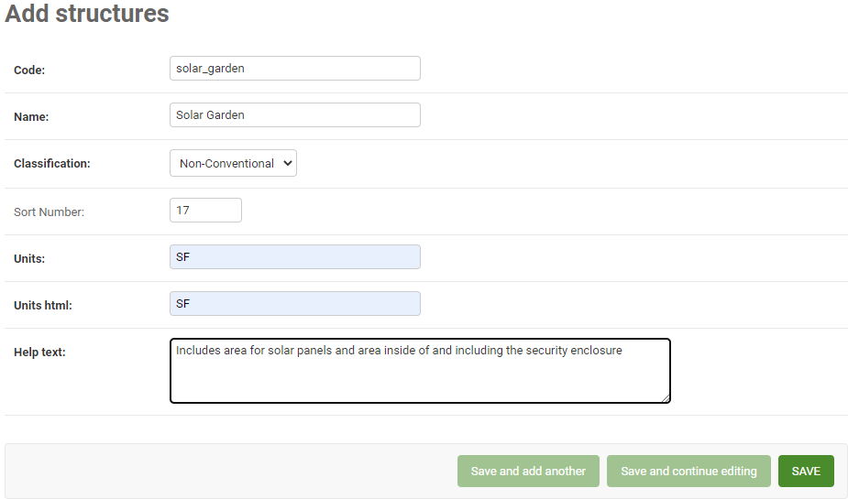

On the list of Structures, the new entry should be displayed in a banner, and then added to the list.

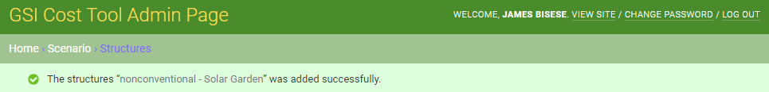



**Structure / Cost Item Default Factors**

Before the Structure can be used in a Scenario, the super user must create 'Structure Cost Item Default Factors' to provide default Cost items for the Structure. For the 'Solar Garden' example, the super user might want to add 4 default Cost items – 'Clearing and Grubbing' (site preparation), 'Engineered Media' (for the ground cover under the solar panels), and 'Erosion Control' (to capture required erosion mitigation).

To review, and create, new 'Structure Cost Item Default Factors', select the option from the Site administration list. The information displayed on the admin page is the same shown in the Reference page.

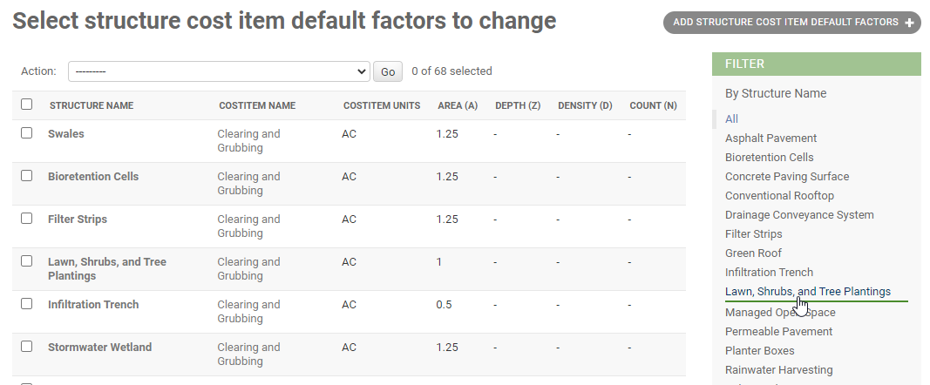

The super user can select 'Solar Garden' from the FILTER list on the right to show that it starts empty - there are no defaults

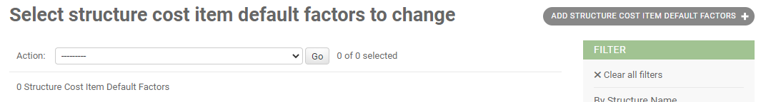

To create new value – use the button 'ADD STRUCTURES COST ITEM DEFAULT FACTORS' in the upper right corner.

In the screen that opens, enter the information for the new item. Select 'nonconventional – Solar Garden' from the list of Structures, and then 'Clearing and Grubbing' from the list of Cost Items. For Clearing and Grubbing only Area is used, so enter 1 to use the default that the entire area will be used to calculate the cost. Then hit the SAVE button on the lower right corner of the screen.

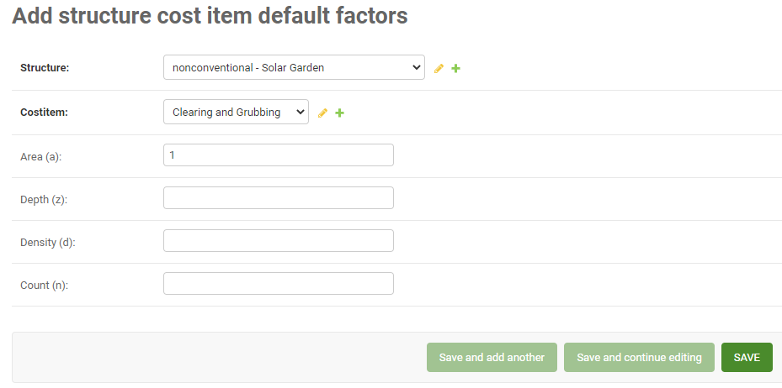

Repeat this process for the other 2 default cost items. When all 3 are set up the list is displayed.

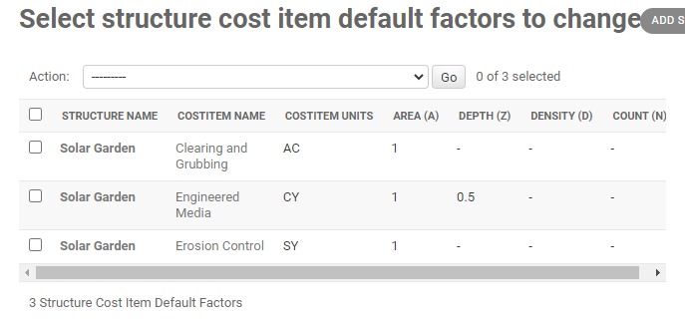

**Review in GSI Cost Tool**

Now that the new Structure is configured – it can be used by users in the GSI Cost Tool. Users will find the new Structure on the Structures tab, in either the Non-Conventional Structures or Conventional Structures list.

To enter an area for the new Solar Garden structure, check the checkbox, and then enter an area in square feet.

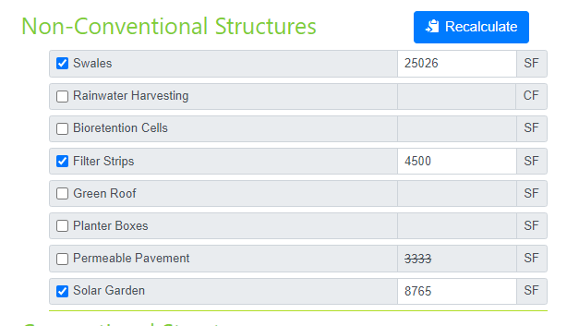

On the Structure/Cost Item User Factors tab the Solar Garden structure will be displayed in the drop-down list. When Solar Garden is selected, the values created earlier are displayed.

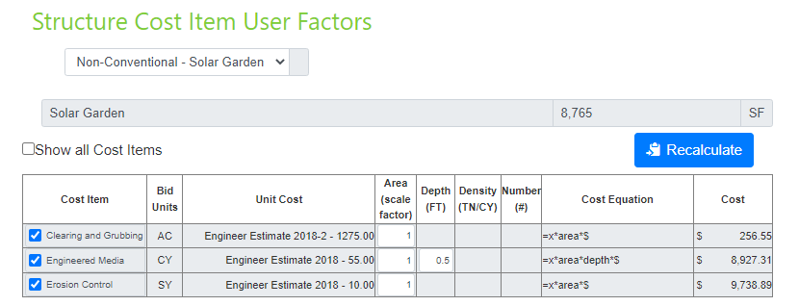

**Note**: *this is a good example of why a new Cost Item might be needed. In this example, there is no way to record either the cost of the Solar Panels, or of the Chain Link Fence that might be needed for a security enclosure. Creating and configuring those is shown in the 'Adding a new Cost Item' documentation.*